Erin Mandell

October 11, 2019

WeatherPy Report

The WeatherPy exercise required us to analyze whether or not the latitude of a location correlates with various weather patterns. We did this by randomly selecting 1500 lat/lon combinations using CityPy, and then linking to OpenWeatherMapy to retrieve the current weather conditions at the cities nearest those coordinates.

Our first graph shows that Latitude and Max Temperature correlate. In this graph, which is a snapshot of the weather on October 11, 2019, we see that temperatures decrease when latitudes increase (when we traverse farther north). Those cities located at or near the equator (0 latitude) have the highest measured temperatures. And then temperatures begin to drop again as we move farther south and away from the equator.

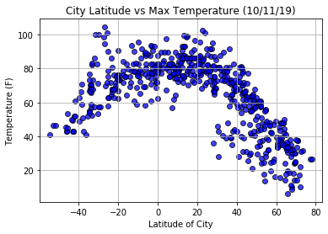

The results reflected in this graph are interesting. Latitude does not seem to correlate with humidity to an exceptional until the latitude is greater than about 52, at which time the humidity results are consistently higher (above 50 %). Environments nearer the equator may be either humid (think jungle) or dry (think desert). Environments farther north however are more humid even when a desert. Ulaan Baatar in the Gobi desert Mongolia recorded a humidity reading of 57% today, and additional internet research shows that the average humidity there year round is 60%. I would conclude from this data that those locations farther north of the equator do not often experience dry weather.

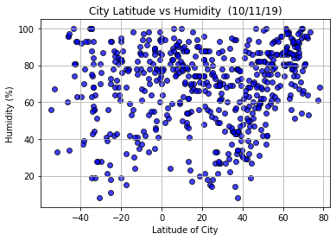

This chart reveals virtually no correlation whatsoever between latitude and cloudiness, except perhaps at latitudes of 60 or greater where there is a greater likelihood of cloudiness. This is consistent with the previous two graphs as increased cloudiness would often result in higher humidity (clouds indicating the presence of moisture) and reduced temperatures (earth’s surface is not being warmed by access to sunlight).

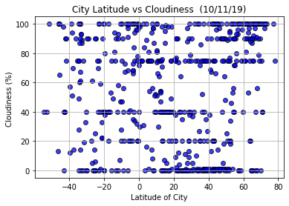

This final chart demonstrates no correlation whatsoever between latitude and wind speed, with the notable exception of the first three data points which are at a latitude of approximately -50. These three data points might lead one to believe that very southern latitudes in and of themselves correlate to higher wind speed, but in actually these data points represent the southern tip of South America in Argentina and Chile and reflect the unique weather patterns with high winds during the summer months in the Tierra Del Fuego archipelago.

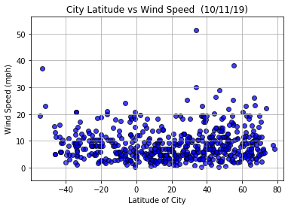

In summary, other than maximum temperatures, latitude does not strongly correlate with humidity, cloudiness, or wind speed except at the highest and lowest latitudes. The correlation with temperature is strong, however. One weakness with this data set is that the weather readings are limited to those taken at cities with populations greater than a certain number (ref CityPy documentation). If we were to include data from weather stations in more locations in southern latitudes, we would see symmetry in the Max Temperature graph, and might likely see more symmetry in the Humidity and Cloudiness graphs.